**B Tech IT - B**

**Keerthanan G B I**

**CC - 1**

***Task – 1***

package CodingContest1;

import org.openqa.selenium.By;

import org.openqa.selenium.WebDriver;

import org.openqa.selenium.WebElement;

import org.openqa.selenium.chrome.ChromeDriver;

import org.openqa.selenium.chrome.ChromeOptions;

import org.testng.annotations.Test;

import io.github.bonigarcia.wdm.WebDriverManager;

public class Task1 {

*@Test*

public void f() {

WebDriverManager.*chromedriver*().setup();

WebDriver driver;

ChromeOptions co=new ChromeOptions();

co.addArguments("--remote-allow-origins=*");

driver=new ChromeDriver(co);

driver.get("https://www.saucedemo.com/");

WebElement cusid=driver.findElement(By.*id*("user-name"));

cusid.sendKeys("standard_user");

WebElement cusid1=driver.findElement(By.*id*("password"));

cusid1.sendKeys("secret_sauce");

WebElement submit=driver.findElement(By.*id*("login-button"));

submit.click();

WebElement addtocart = driver.findElement(By.*id*("add-to-cart-sauce-labs-backpack"));

addtocart.click();

WebElement yourorder=driver.findElement(By.*xpath*("//*[@id=\"shopping_cart_container\"]/a"));

yourorder.click();

WebElement addtocart1 = driver.findElement(By.*id*("checkout"));

addtocart1.click();

WebElement cusid11=driver.findElement(By.*id*("first-name"));

cusid11.sendKeys("keerthanan");

WebElement cusid111=driver.findElement(By.*id*("last-name"));

cusid111.sendKeys("G B I");

WebElement cusid1111=driver.findElement(By.*id*("postal-code"));

cusid1111.sendKeys("636001");

WebElement addtocart11 = driver.findElement(By.*id*("continue"));

addtocart11.click();

System.***out***.println("Name of the product : "+ driver.findElement(By.*xpath*("/html/body/div/div/div/div[2]/div/div[1]/div[3]/div[2]/a/div")).getText());

System.***out***.println("Price of the product : "+ driver.findElement(By.*xpath*("/html/body/div/div/div/div[2]/div/div[1]/div[3]/div[2]/div[2]/div")).getText());

if(driver.getTitle().equals("Swag Labs")) {

System.***out***.println("Title matched");

}

if(driver.getCurrentUrl().equals("https://www.saucedemo.com/checkout-step-two.html")) {

System.***out***.println("URL matched");

}

}

}

***Output :***

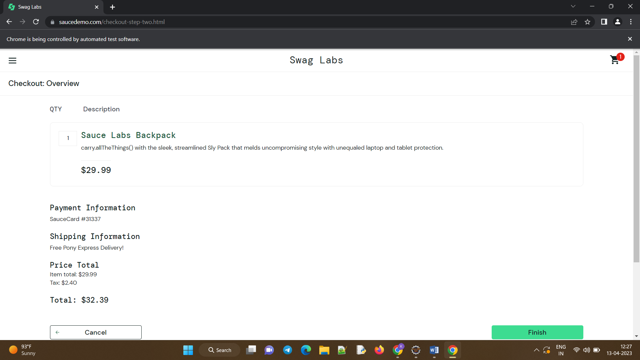

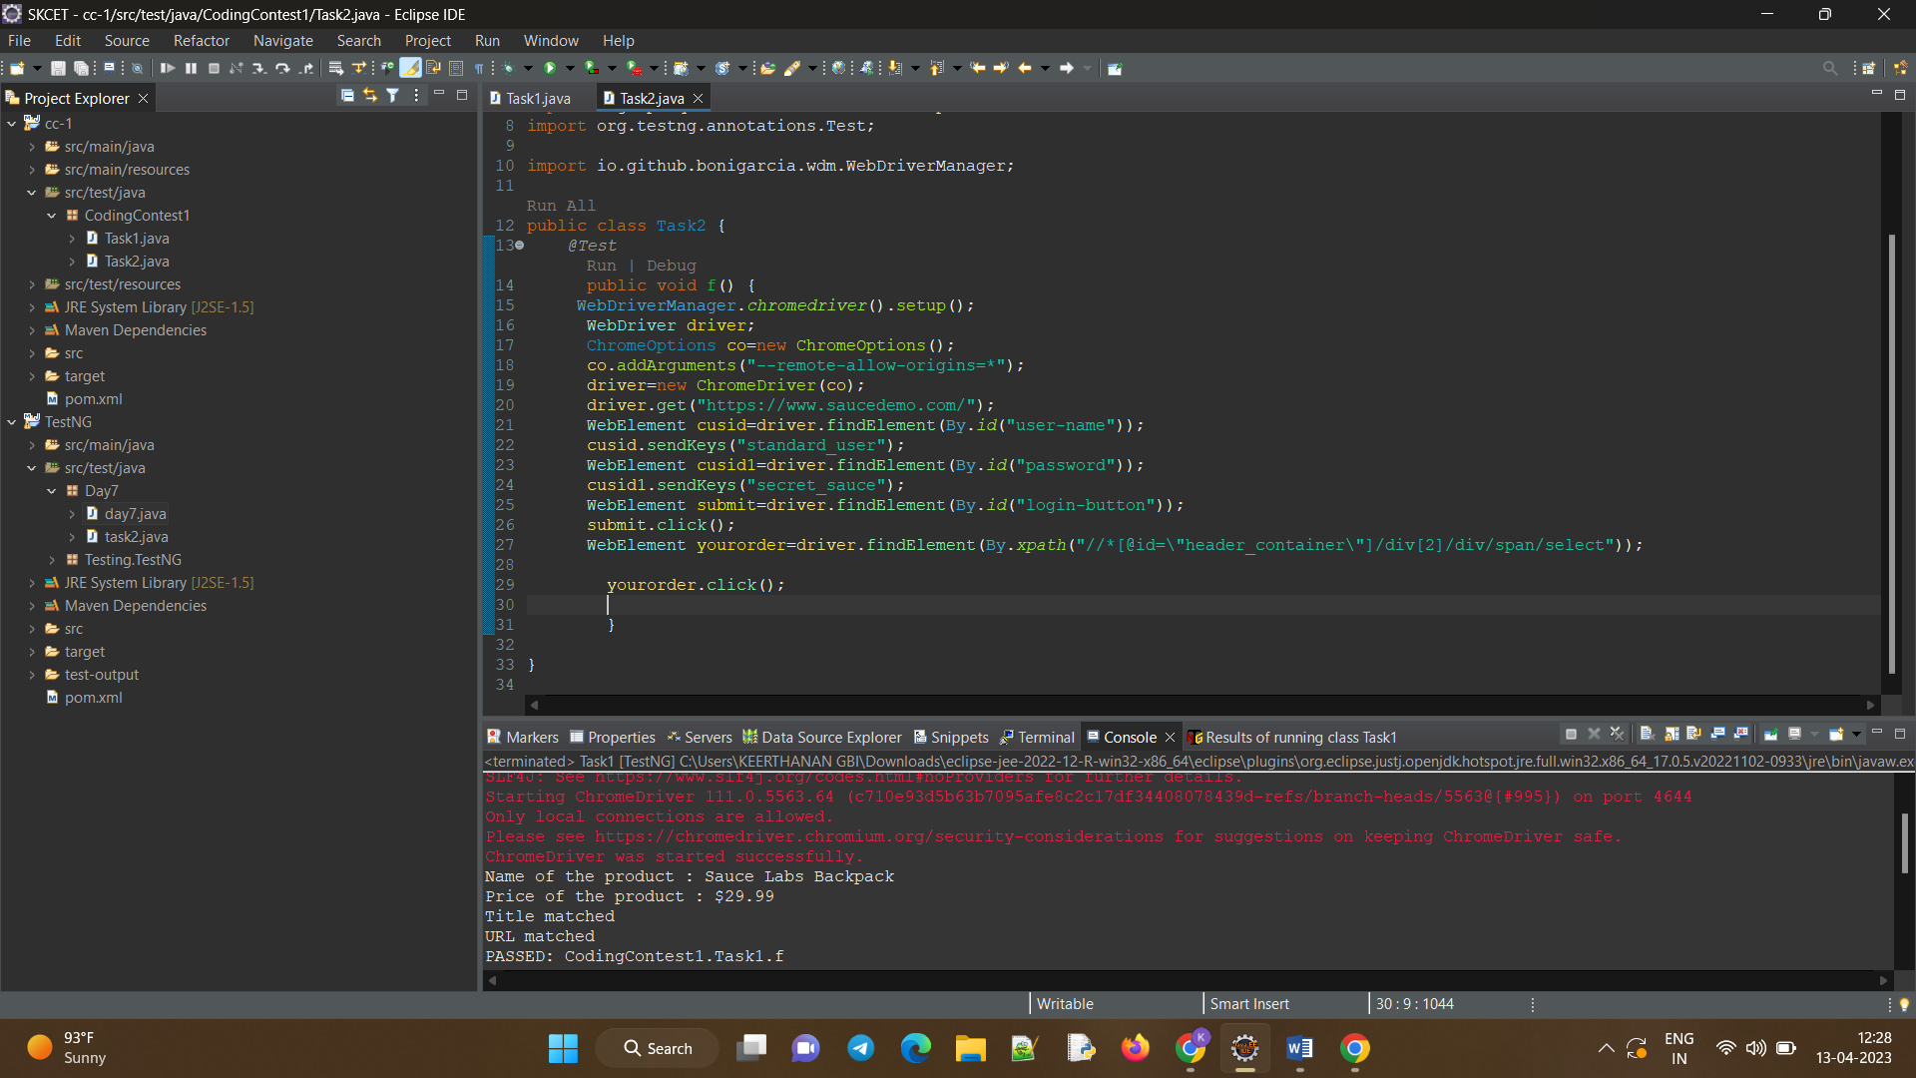

***Task – 2***

package CodingContest1;

import org.openqa.selenium.By;

import org.openqa.selenium.WebDriver;

import org.openqa.selenium.WebElement;

import org.openqa.selenium.chrome.ChromeDriver;

import org.openqa.selenium.chrome.ChromeOptions;

import org.testng.annotations.Test;

import io.github.bonigarcia.wdm.WebDriverManager;

public class Task2 {

*@Test*

public void f() throws InterruptedException {

WebDriverManager.*chromedriver*().setup();

WebDriver driver;

ChromeOptions co=new ChromeOptions();

co.addArguments("--remote-allow-origins=*");

driver=new ChromeDriver(co);

driver.get("https://www.saucedemo.com/");

WebElement cusid=driver.findElement(By.*id*("user-name"));

cusid.sendKeys("standard_user");

WebElement cusid1=driver.findElement(By.*id*("password"));

cusid1.sendKeys("secret_sauce");

WebElement submit=driver.findElement(By.*id*("login-button"));

submit.click();

String txt1=driver.findElement(By.*xpath*("//*[@id=\"item_4_title_link\"]/div")).getText();

System.***out***.println(txt1);

driver.findElement(By.*xpath*("//*[@id=\"header_container\"]/div[2]/div/span/select")).click();

driver.findElement(By.*xpath*("//*[@id=\"header_container\"]/div[2]/div/span/select/option[2]")).click();

String txt2=driver.findElement(By.*xpath*("//*[@id=\"item_3_title_link\"]/div")).getText();

System.***out***.println(txt2);

driver.findElement(By.*xpath*("//*[@id=\"header_container\"]/div[2]/div/span/select")).click();

driver.findElement(By.*xpath*("//*[@id=\"header_container\"]/div[2]/div/span/select/option[3]")).click();

String txt3=driver.findElement(By.*xpath*("//*[@id=\"item_2_title_link\"]/div")).getText();

System.***out***.println(txt3);

driver.findElement(By.*xpath*("//*[@id=\"header_container\"]/div[2]/div/span/select")).click();

driver.findElement(By.*xpath*("//*[@id=\"header_container\"]/div[2]/div/span/select/option[4]")).click();

String txt4=driver.findElement(By.*xpath*("//*[@id=\"item_5_title_link\"]/div")).getText();

System.***out***.println(txt4);

Thread.*sleep*(5000);

}

}

***Output:***

